**KUIS PRAKTIKUM**

**Politeknik Negeri Malang**

**Praktikan**

**ALGORITMA DAN STRUKTUR DATA**



2022

2141720183

RIDWAN CAESAR RIZQI KARISMA BIWARNI

TI 1C

Daftar Isi

Kuis 3

Source code 3

Output Nomor 1 Tambah Antrian 8

Output Nomor 2 Cetak Antrian 9

Output Nomor 3 Hapus Antrian 9

Output Nomor 4 Laporan pesanan (urut by Nama) 10

Output Nomor 5 Hitung total pendapatan 10

# Kuis

## Source code

DoubleLinkedList_26

*public class* DoubleLinkedList_26 {  
 Node_26 head;  
 NodePesanan_26 headPesanan;  
 *int* size;  
  
 DoubleLinkedList_26() {  
 head = *null*;  
 size = 0;  
 }  
 *public boolean* isEmpty() {  
 *return* head == *null*;  
 }  
  
 *public void* addFirst(Pembeli_26 item) {  
 *if* (isEmpty()) {  
 head = *new* Node_26(*null*, item, *null*);  
 } *else* {  
 Node_26 newNode = *new* Node_26(*null*, item, head);  
 head.prev = newNode;  
 head = newNode;  
 }  
 size++;  
 }  
 *public void* addLast(Pembeli_26 item) {  
 *if* (isEmpty()) {  
 addFirst(item);  
 } *else* {  
 Node_26 current = head;  
 *while* (current.next != *null*) {  
 current = current.next;  
 }  
 Node_26 newNode = *new* Node_26(current, item, *null*);  
 current.next = newNode;  
 size++;  
 }  
 }  
 *public void* print() {  
 *if* (!isEmpty()) {  
 Node_26 tmp = head;  
 System.out.println("No.\t\t|Nama Customer\t\t|No HP");  
 *while* (tmp != *null*) {  
 System.out.println("|" + tmp.data.antrian + "\t\t|" + tmp.data.namaPembeli + "\t\t|" + tmp.data.NoHP);  
 tmp = tmp.next;  
 }  
 } *else* {  
 System.out.println("Linked Lists Kosong");  
 }  
 }  
 *public void* removeFirst() *throws* Exception {  
 *if* (isEmpty()) {  
 *throw new* Exception("Antrian masih kosong, tidak dapat dihapus");  
 } *else if* (size == 1) {  
 removeLast();  
 } *else* {  
 System.out.println(head.data.namaPembeli + " telah memesan Menu");  
 head = head.next;  
 head.prev = *null*;  
 size--;  
 }  
 }  
 *public void* removeLast() *throws* Exception {  
 *if* (isEmpty()) {  
 *throw new* Exception("Antrian masih kosong, tidak dapat dihapus");  
 } *else if* (head.next == *null*) {  
 head = *null*;  
 size--;  
 *return*;  
 }  
 Node_26 current = head;  
 *while* (current.next.next != *null*) {  
 current = current.next;  
 }  
 current.next = *null*;  
 size--;  
 }  
  
}

DoubleLinkedListPesanan_26

*public class* DoubleLinkedListPesanan_26 {  
 NodePesanan_26 head;  
 *int* size;  
  
 DoubleLinkedListPesanan_26() {  
 head = *null*;  
 size = 0;  
 }  
 *public boolean* isEmpty() {  
 *return* head == *null*;  
 }  
 *public void* addFirst(Pesanan_26 item) {  
 *if* (isEmpty()) {  
 head = *new* NodePesanan_26(*null*, item, *null*);  
 } *else* {  
 NodePesanan_26 newNode = *new* NodePesanan_26(*null*, item, head);  
 head.prev = newNode;  
 head = newNode;  
 }  
 size++;  
 }  
 *public void* addLast(Pesanan_26 item) {  
 *if* (isEmpty()) {  
 addFirst(item);  
 } *else* {  
 NodePesanan_26 current = head;  
 *while* (current.next != *null*) {  
 current = current.next;  
 }  
 NodePesanan_26 newNode = *new* NodePesanan_26(current, item, *null*);  
 current.next = newNode;  
 size++;  
 }  
 }  
 *public void* print() {  
 *if* (!isEmpty()) {  
 NodePesanan_26 tmp = head;  
 System.out.println("No.\t\t|Nama Pesanan\t\t|Harga");  
 *while* (tmp != *null*) {  
 System.out.println("|" + tmp.data.kodePesanan + "\t\t|" + tmp.data.namaPesanan + "\t\t|" + tmp.data.harga);  
 tmp = tmp.next;  
 }  
 System.out.println("\nberhasil diisi");  
 } *else* {  
 System.out.println("Linked Lists Kosong");  
 }  
 }  
  
 *public void* sortByNama() {  
 NodePesanan_26 current, index;  
 Pesanan_26 tmp;  
 *if* (isEmpty()) {  
 System.out.println("Data Linked list kosong");  
 } *else* {  
 *for* (current = head; current.next != *null*; current = current.next) {  
 *for* (index = current.next; index != *null*; index = index.next) {  
 *if* (current.data.namaPesanan.compareTo(index.data.namaPesanan) > 0) {  
 tmp = current.data;  
 current.data = index.data;  
 index.data = tmp;  
 }  
 }  
 }  
 }  
 print();  
 }  
  
 *public int* totalPendapatan() {  
 *int* total = 0;  
 *if* (!isEmpty()) {  
 NodePesanan_26 tmp = head;  
 *while* (tmp != *null*) {  
 total += tmp.data.harga;  
 tmp = tmp.next;  
 }  
 } *else* {  
 System.out.println("Linked Lists Kosong");  
 }  
 *return* total;  
 }  
}

Main_26

*import* java.util.Scanner;  
  
*public class* Main_26 {  
 *public static* Scanner input = *new* Scanner(System.in);  
 *public static void* main(String[] args) *throws* Exception {  
 System.out.println("===== QUIZ 2 PRAKTIKUM ASD TI - 1C DAN TI - 1F =====");  
 System.out.println("dibuat oleh : Ridwan Caesar Rizqi Karisma Biwarni");  
 System.out.println("NIM : 2141720183");  
 System.out.println("Absen : 26");  
 System.out.println("====================================================");  
 System.out.println("Sistem Antrian Resto Royal Delish");  
 DoubleLinkedList_26 dll = *new* DoubleLinkedList_26();  
 DoubleLinkedListPesanan_26 dllPesanan = *new* DoubleLinkedListPesanan_26();  
 *int* menu;  
 *// penambahan data tanpa input data melalui keyboard* dll.addLast(*new* Pembeli_26("Ridwan","085131232", 1));  
 dll.addLast(*new* Pembeli_26("Caesar","082142412", 2));  
 dll.addLast(*new* Pembeli_26("Rizqi","0842142142", 3));  
 *int* noAntrian = 1;  
 *do* {  
 System.out.println("Menu");  
 System.out.println("1. Tambah Antrian");  
 System.out.println("2. Cetak Antrian");  
 System.out.println("3. Hapus Antrian");  
 System.out.println("4. Laporan Pengurutan pesanan by nama");  
 System.out.println("5. Hitung total Pendapatan");  
 System.out.println("6. Keluar");  
 System.out.print("Pilih (1-6):");  
 menu = input.nextInt();  
 *switch* (menu) {  
 *case* 1 -> {  
 System.out.println("---------------");  
 System.out.println("Masukkan Data Pembeli");  
 System.out.println("---------------");  
 System.out.println("Nomor Antrian : " + (dll.size + 1));  
 System.out.print("Nama Customer : ");  
 String namaCustomer = input.next();  
 input.nextLine();  
 System.out.print("Nomor Hp : ");  
 String noHP = input.nextLine();  
 Pembeli_26 newPembeli = *new* Pembeli_26(namaCustomer, noHP, (dll.size + 1));  
 dll.addLast(newPembeli);  
 }  
 *case* 2 -> {  
 System.out.println("++++++++++++++++");  
 System.out.println("Daftar Antrian Resto Royal Delish");  
 System.out.println("++++++++++++++++");  
 dll.print();  
 }  
 *case* 3 -> {  
 dll.removeFirst();  
 System.out.println("------------------");  
 System.out.println("Transaksi input pesanan");  
 System.out.println("------------------");  
 System.out.println("Nomor Pesanan : " + (dllPesanan.size + 1));  
 System.out.print("Pesanan : ");  
 String pesanan = input.next();  
 input.nextLine();  
 System.out.print("Harga : ");  
 *int* harga = input.nextInt();  
 Pesanan_26 newPesanan = *new* Pesanan_26((dllPesanan.size + 1),pesanan, harga);  
 dllPesanan.addLast(newPesanan);  
 dllPesanan.print();  
 }  
 *case* 4 -> {  
 System.out.println("++++++++++");  
 System.out.println("Daftar Pesanan Masuk Resto Royal Delish");  
 System.out.println("++++++++++");  
 dllPesanan.sortByNama();  
 }  
 *case* 5 -> {  
 System.out.println("++++++++++++");  
 System.out.println("Total Pendapatan");  
 System.out.println("++++++++++++");  
 System.out.println("Pendapatan hari ini " + dllPesanan.totalPendapatan());  
 }  
 *case* 6 -> {  
 System.exit(0);  
 }  
 }  
 } *while* (menu >= 1 && menu <= 6);  
 }  
}

Node_26

*public class* Node_26 {  
 Pembeli_26 data;  
 Node_26 prev, next;  
  
 Node_26(Node_26 prev, Pembeli_26 data, Node_26 next) {  
 *this*.prev = prev;  
 *this*.data = data;  
 *this*.next = next;  
 }  
}

NodePesanan_26

*public class* NodePesanan_26 {  
 Pesanan_26 data;  
 NodePesanan_26 prev, next;  
  
 NodePesanan_26(NodePesanan_26 prev, Pesanan_26 data, NodePesanan_26 next) {  
 *this*.prev = prev;  
 *this*.data = data;  
 *this*.next = next;  
 }  
}

Pembeli_26

*public class* Pembeli_26 {  
 String namaPembeli;  
 String NoHP;  
 *int* antrian;  
  
 Pembeli_26(String b, String c, *int* d) {  
 namaPembeli = b;  
 NoHP = c;  
 antrian = d;  
 }  
}

Pesanan_26

*public class* Pesanan_26 {  
 *int* kodePesanan;  
 String namaPesanan;  
 *int* harga;  
  
 Pesanan_26(*int* a, String b, *int* c) {  
 kodePesanan = a;  
 namaPesanan = b;  
 harga = c;  
 }  
}

## Output Nomor 1 Tambah Antrian

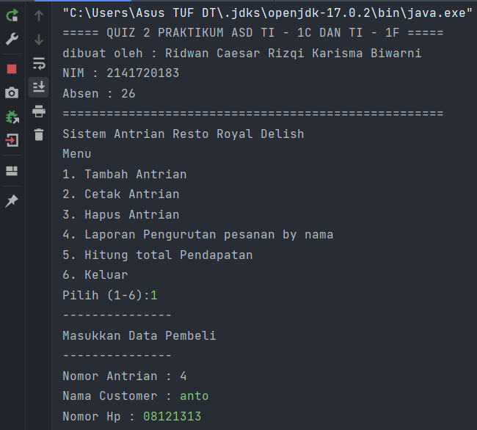

## Output Nomor 2 Cetak Antrian

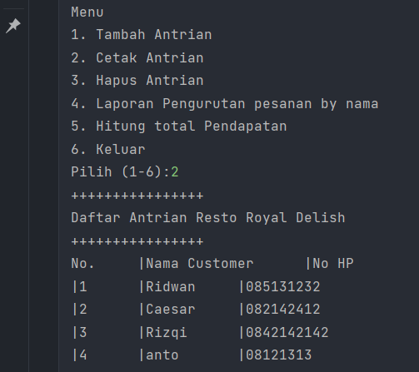

## Output Nomor 3 Hapus Antrian

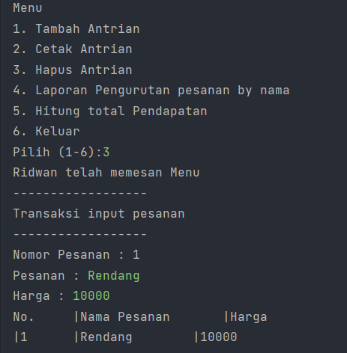

Dan saat sukses mengembalikan maka antrian berkurang.

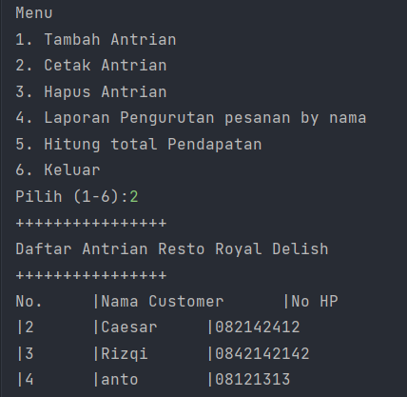

## Output Nomor 4 Laporan pesanan (urut by Nama)

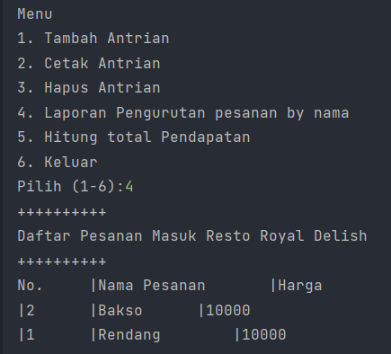

## Output Nomor 5 Hitung total pendapatan

Total pendapatan 20000 karena ada 2 pesanan bakso dan rendang yang masing-masing berharga 10000

